

ArchAngel
Perfect, again.

Create higher quality, better designed software in a fraction of the time. ArchAngel enables development teams to experience gains in productivity and quality which far surpass current industry norms. In essence, ArchAngel is an architecture-generator which creates best-practice, high-quality applications extremely quickly. Existing attempts at realising the full potential of this approach are hindered by the fact that generated solutions need to be treated far more carefully than ‘normal’ code. This is because re-generation overwrites any changes made to the previously generated code. ArchAngel solves this problem, freeing development teams to work in a non-restrictive manner that feels comfortable to them, while still realising the full benefits of an automated approach. ArchAngel has many other potential uses, such as auto-creation of database migration scripts, to move data from a legacy database to a new database.

Benefits to Company
- Save time - Deliver projects substantially faster than they normally take.
- Ultra Consistent design - You are assured that all projects will use exactly the same architecture that you have chosen to use. All your projects will ‘work the same’.
- Better designed software – Best practices are incorporated into the templates. When ArchAngel is used you can be sure that the generated code implements best practices.
- Save money – Development costs are reduced. Support costs are reduced. Timeframes are shortened.
- Increased project predictability – Schedule overruns are reduced due to smaller proportion of hand-written (error-prone, costly, time-consuming) code.
- Complete architecture generation – ArchAngel takes a holistic approach, and creates the entire architecture, ready for compilation. Even binary files can be included in the output. Many existing solutions generate a single file at a time.
- Higher quality – Fewer defects. The bug habitat of code is dramatically reduced because generated code is usually bug-free and optimised. This means that the amount of code in which bugs can exist (buggy hand-written code) is minimised as it occupies a much smaller portion of the entire code-base. Higher quality reduces support costs and improves customer satisfaction.
- Shorter ramp-up time for new hires - Due to the consistent design, new developers will only need to learn your chosen architecture, and subsequently understand the architecture of all your projects. This allows them to become productive far quicker.
- Suits agile development – Agile development is based on fast iterations, so ArchAngel fits well with this methodology. ArchAngel fits well with other methodologies as well.

Benefits to Developers
- Best practices - Once industry best practices are embodied in templates, they will automatically be used by all your projects, assuring you that your projects/products are of a consistently high design quality.
- Full round-trip support – Unlike existing solutions which provide a kick-start to projects but no further help after the initial generation, ArchAngel helps developers throughout the lifecycle of the project. Using IntelliMerge, changes to the database can be quickly assimilated into the project. Generated code can be treated like normal hand-crafted code and modified at will when required without the fear of losing the work when the next generation occurs.
- Intuitively designed – ArchAngel has an inductive user interface, and most users are able to become productive very quickly.
- No weird rules. No code off-limits – Existing solutions force you to jump through hoops when dealing with generated code, but thanks to IntelliMerge those days are over. There is no need to carefully ensure that generated code is only modified between special markers, or not modifiable at all, or that generated classes need to be inherited from to make changes. Code is just that – code. Own it, and treat it as you will. IntelliMerge makes sure your hours of hard work are not lost when re-generating.
- Output is fully modifiable to meet unique requirements
- Test numerous architectures – Due to the ease of creating new projects, architects and team leaders are able to test numerous architectures in the environment before deciding which one best suits the project. This analysis is traditionally paper-based or based on experience, resulting in sub-optimal architectures being selected. The chosen architecture can still be changed at a later stage and regenerated.
- Powerful mentor – The generated code teaches developers good design and best practices. Empower your developers with best architectural knowledge. Senior architects create and modify the templates. Junior and intermediate developers can inspect the code they produce using ArchAngel and gain knowledge and skills of how to best design robust systems.
- Higher job satisfaction - Developers can focus on the interesting aspects of developing a system such as business rules and functionality, because the base architecture (design) has already been taken care of by ArchAngel and the boring, repetitive coding such as the data access layer is taken care of by ArchAngel.

Benefits to Clients
- Feature-creep allowed – Applying database modifications to existing code now has a low impact on project schedules, thanks to the safety provided by IntelliMerge. Limited feature requests are permissible mid-project, leading to happier clients. This is very different from today’s projects that need to fight feature-creep to keep costs down and schedules on track.
- Quick iteration cycles – Iterations are cheap, and therefore clients are able to see their project’s progress far more frequently.

Differentiating Features
- IntelliMerge - Existing products make it extremely difficult to change generated code, because a re-generation will overwrite any changes made. Complex workarounds are required, such as only being able to insert code in specially marked sections; requiring classes to be sub-classed if changes are to be made. Generally, generated code has to be dealt with using extreme caution. IntelliMerge mitigates all of this and allows changes to be made at will. For a full description of IntelliMerge see below.
- Complex database mapping - No template-based code-generators are able to map single objects to multiple tables, and vice versa. ArchAngel allows the user to do this, exposing these properties via the scripting API used when creating a template. Most existing solutions force a one-to-one mapping between generated classes and database tables.
- Multi-database mapping – Map multiple databases to a single project. All existing solutions only handle a single database.
- Generation of entire projects - ArchAngel provides the ability to generate entire hierarchies of files. These files can be generated files as well as included binary files, such as images for web-pages etc. This means that at a click of a button an entire project can be created, ready to compile. Most existing products generate single files at a time.
- No vendor lock-in – No reliance on 'special' libraries - you can stop using ArchAngel at any point in time and use the code as if you had hand-crafted it yourself. Some existing solutions require use of proprietary files, another form of lock-in.
- Multiple architectures – Many different architectures to choose from, or modify them to meet your needs. Even roll your own to match your company’s standards. Some competitors only support a single architecture which they deem 'the best' – no architecture is the best in every situation.
- Legacy database support – Due to the advanced mapping features, ArchAngel is a great solution for companies with significant investments in legacy databases, providing them with a very cost effective way to move forward and create new, well-designed applications without being hindered by legacy database issues.

Features
- Fully customizable - Template-based architecture-generation
- Text output – ArchAngel generates pure text, allowing the user to generate code for any text-based language, such as C#, Java, C++, VB.net, Perl, Python, PHP etc. It can even generate reports, HTML, CSV etc.
- Powerful template-editor – Create or edit templates with IntelliSense (statement completion), integrated debugging.
- IntelliMerge – When code is re-generated a second or subsequent time, any changes that developers made to the previous generation will be automatically merged into the newly generated code, even if functions have been rearranged or renamed. In those instances where a conflict is found and the changes cannot be automatically merged, the user is presented with tools to specify what changes should be accepted.
- Single file templates - Entire architectures are defined in a single file making it easy to distribute. It can even include binary files such as images for web-pages, or PDF documents.
- Supports all database relationships - One-to-one, one-to-many, many-to-many.
- Add missing relationships - Missing relationships can be added before generation. Users can add explicit relationships between tables when they are missing from the actual database due to bad design and years of legacy modifications.
- Model independence – The model can be modified independently of the database, then mapped to the actual databases. This means that the existing bad database designs do not necessitate bad code design - they can be modified independently of each other.
- Auto-formatting – Users can choose ArchAngel to automatically format the generated code, based on user-selectable criteria. This even includes advanced options such as re-ordering functions alphabetically etc. It allows company standards to be applied to generated code.
- Friendly user interface – All ArchAngel properties and settings are accessible via a well-designed user interface – no messing about with configuration files etc.
- Import existing templates – Import CodeSmith and MyGeneration templates. Support for others will be added.
- Multiple script languages – Script can be created in C#, VB.net, J#.

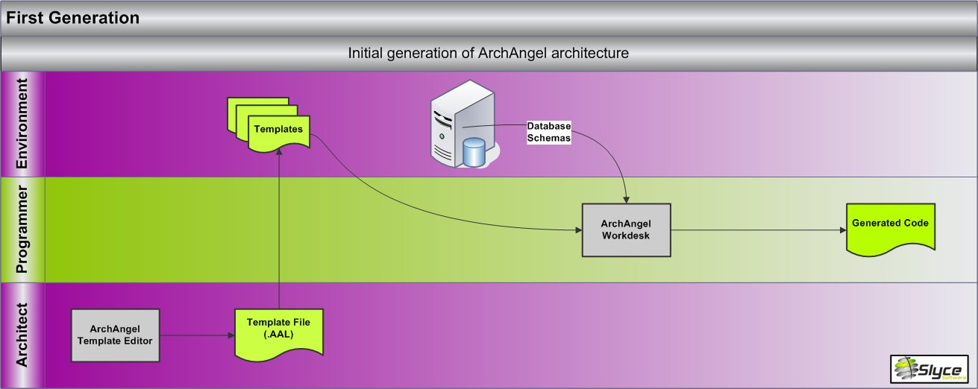

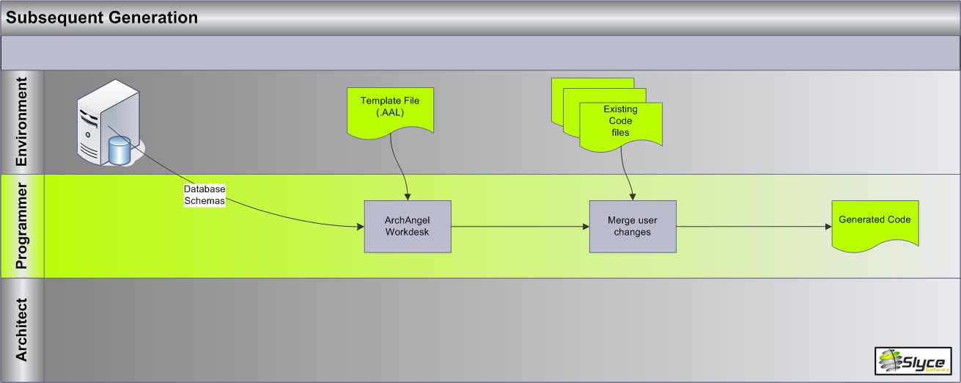

Templates
A number of templates are provided with the installation. You can modify these to meet your needs, or design your own based on your company’s existing architecture. Many others will be added over time, through the online template library and user submissions.

- PetShop 3.0 (C#)
- Microsoft Data Access Application Block (VB.net)
- Microsoft Data Access Application Block (C#)
- NHibernate (C#)
- Gentle.net
- CSLA (VB.net)
- WilsonORMapper Framework

Customer Profile
- Large corporations with significant investments in legacy databases that are holding them back from forward progress. Companies with years of investment in legacy databases often find their development efforts constrained by the bad design of these systems. Development of new applications takes far longer than it should, and the resulting applications are often fragile. The approach often proposed is to create new well-designed databases and migrate the data, but this is usually not feasible because many other applications still use these databases. ArchAngel enables these companies to design new applications properly and connect to the legacy databases. At some future point the legacy databases might start getting fixed or moved. When this happens then the ArchAngel model only needs to get remapped to the new databases. After regeneration the applications will work as before, except they will now be using the new databases.
- Software houses and corporate development teams producing custom data-centric applications.

